JALA HOME SOLUTION
Bed Sheet Catalog
2026 Collection
C-Bedsheet Cotton Satin 5 designs · Rs. 2,000
C Cotton Bedsheet 4pcs Rs. 4,200
C Bedsheet + Quilt Cover Patlaa 4 colours · Rs. 5,700
C Bedsheet + Quilt Cover Motaa Rs. 7,500
C Quilt Cover King Rs. 4,000
C Bedsheet Set 4pc Rs. 6,000
C Towel Bedsheet + Pillow Cover Rs. 2,500
C Single Bedsheet Set 3 designs · Rs. 4,500

C-BEDSHEET COTTON SATIN

Botanical Sketch
A sketchbook come to life in soft charcoal linework.
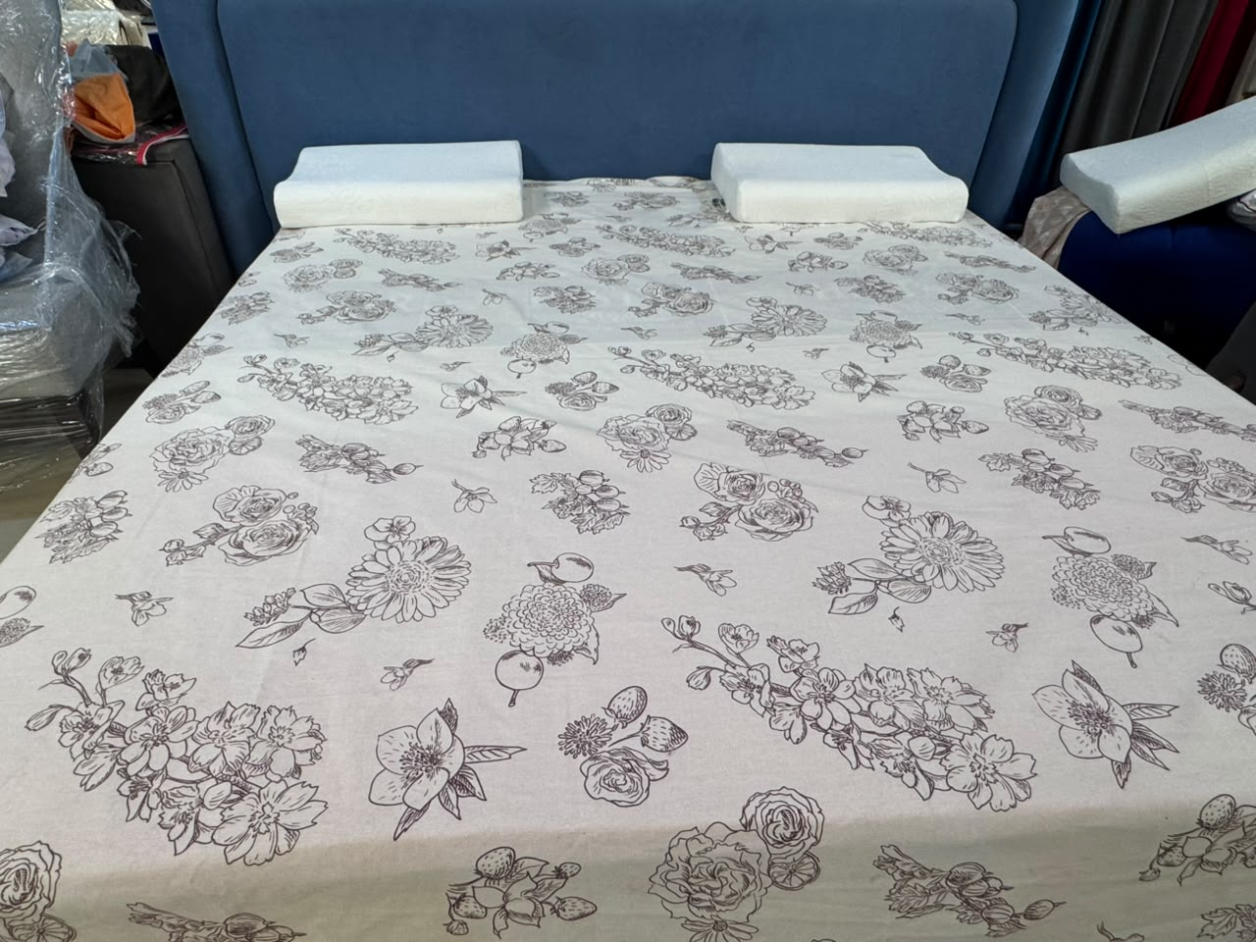
Rs. 3,000 Rs. 2,000 Save 33%
Includes: 1 x Bed Sheet Only (pillow covers not included)
Fabric: Cotton-Satin Mix
Size: Double
Colors Available: -
Description
Crafted from a soft cotton-satin mix fabric, this quality delivers a smooth, breathable sleeping surface with a fade-resistant, machine-printed finish across every design in the collection.
Features:
Soft and smooth texture provides a comfortable sleeping surface. Breathability helps regulate body temperature during sleep. Absorbs moisture and wicks away sweat, keeping you cool and dry. Hypoallergenic feature makes it a suitable choice for people with sensitive skin. Fast and everlasting colors. Natural and environment friendly.
Note: Colors shade/brightness may slightly differ due to photo shoot effects.

C-BEDSHEET COTTON SATIN

Geometry Square
Bold navy-and-mustard geometry for the modern bedroom.
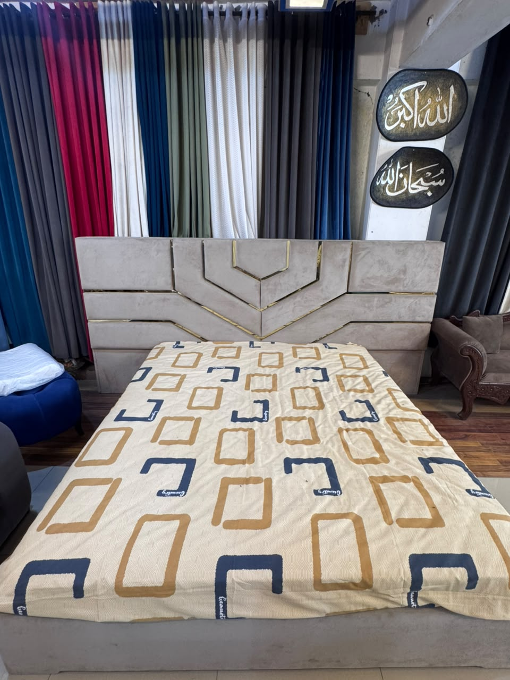
Rs. 3,000 Rs. 2,000 Save 33%
Includes: 1 x Bed Sheet Only (pillow covers not included)
Fabric: Cotton-Satin Mix
Size: Double
Colors Available: -
Description
Crafted from a soft cotton-satin mix fabric, this quality delivers a smooth, breathable sleeping surface with a fade-resistant, machine-printed finish across every design in the collection.
Features:
Soft and smooth texture provides a comfortable sleeping surface. Breathability helps regulate body temperature during sleep. Absorbs moisture and wicks away sweat, keeping you cool and dry. Hypoallergenic feature makes it a suitable choice for people with sensitive skin. Fast and everlasting colors. Natural and environment friendly.
Note: Colors shade/brightness may slightly differ due to photo shoot effects.

C-BEDSHEET COTTON SATIN

Rose Garden
A garden in full bloom, layered petal on petal.
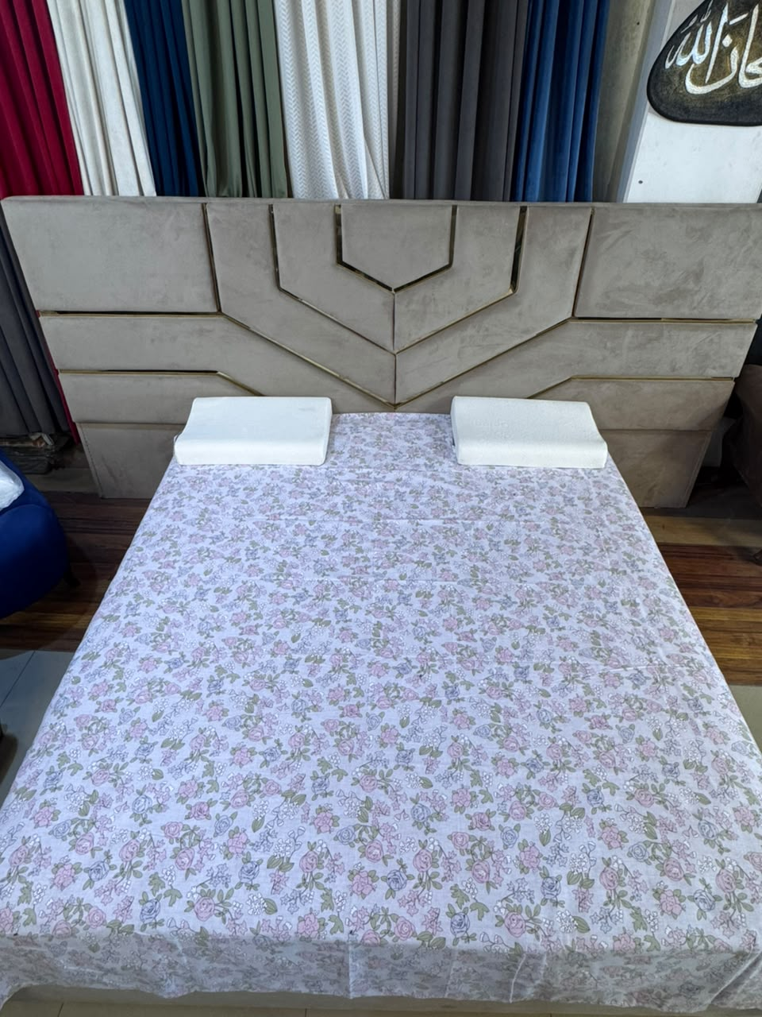
Rs. 3,000 Rs. 2,000 Save 33%
Includes: 1 x Bed Sheet Only (pillow covers not included)
Fabric: Cotton-Satin Mix
Size: Double
Colors Available: -
Description
Crafted from a soft cotton-satin mix fabric, this quality delivers a smooth, breathable sleeping surface with a fade-resistant, machine-printed finish across every design in the collection.
Features:
Soft and smooth texture provides a comfortable sleeping surface. Breathability helps regulate body temperature during sleep. Absorbs moisture and wicks away sweat, keeping you cool and dry. Hypoallergenic feature makes it a suitable choice for people with sensitive skin. Fast and everlasting colors. Natural and environment friendly.
Note: Colors shade/brightness may slightly differ due to photo shoot effects.

C-BEDSHEET COTTON SATIN

Leaf Dot
Rich maroon depth dotted with ivory leaves.
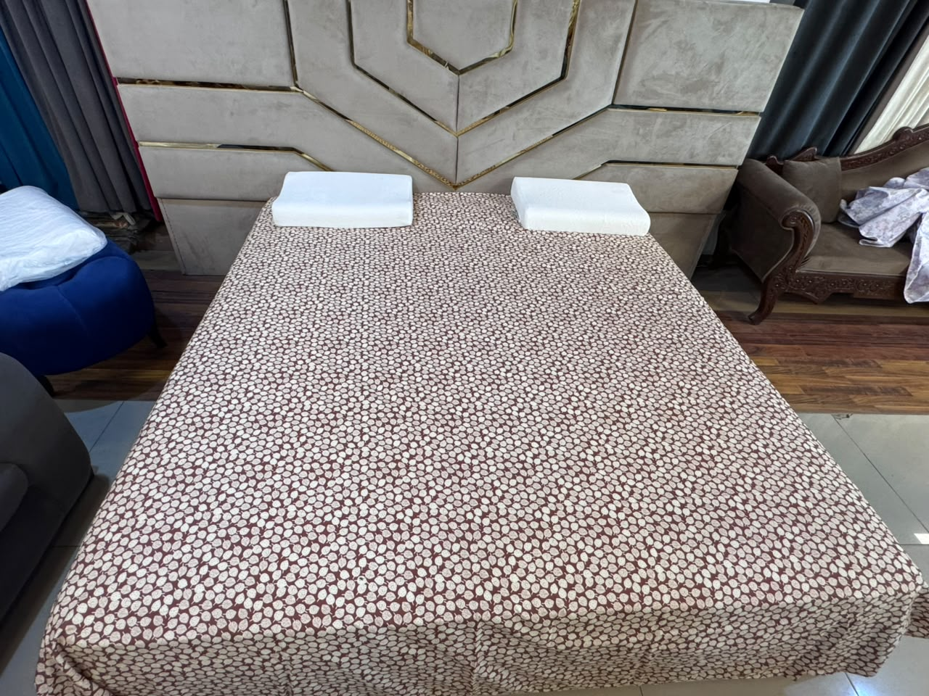
Rs. 3,000 Rs. 2,000 Save 33%
Includes: 1 x Bed Sheet Only (pillow covers not included)
Fabric: Cotton-Satin Mix
Size: Double
Colors Available: -
Description
Crafted from a soft cotton-satin mix fabric, this quality delivers a smooth, breathable sleeping surface with a fade-resistant, machine-printed finish across every design in the collection.
Features:
Soft and smooth texture provides a comfortable sleeping surface. Breathability helps regulate body temperature during sleep. Absorbs moisture and wicks away sweat, keeping you cool and dry. Hypoallergenic feature makes it a suitable choice for people with sensitive skin. Fast and everlasting colors. Natural and environment friendly.
Note: Colors shade/brightness may slightly differ due to photo shoot effects.

C-BEDSHEET COTTON SATIN

Watercolor Blossom
Soft watercolor blooms scattered like a spring breeze.
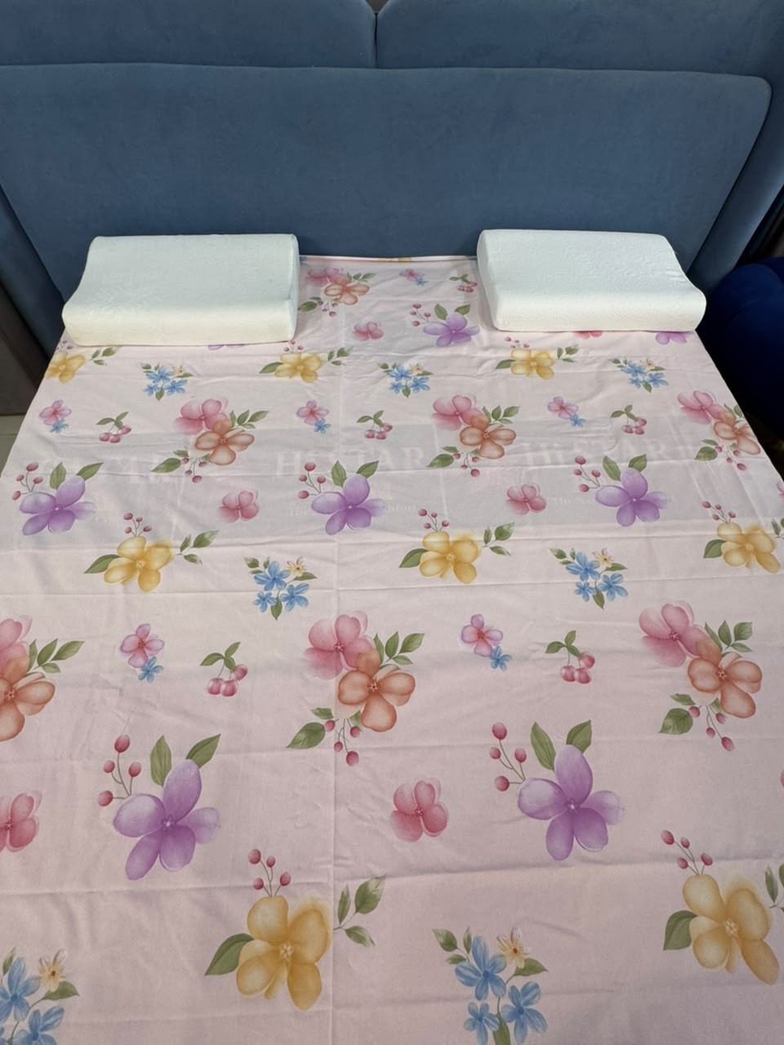
Rs. 3,000 Rs. 2,000 Save 33%
Includes: 1 x Bed Sheet Only (pillow covers not included)
Fabric: Cotton-Satin Mix
Size: Double
Colors Available: -
Description
Crafted from a soft cotton-satin mix fabric, this quality delivers a smooth, breathable sleeping surface with a fade-resistant, machine-printed finish across every design in the collection.
Features:
Soft and smooth texture provides a comfortable sleeping surface. Breathability helps regulate body temperature during sleep. Absorbs moisture and wicks away sweat, keeping you cool and dry. Hypoallergenic feature makes it a suitable choice for people with sensitive skin. Fast and everlasting colors. Natural and environment friendly.
Note: Colors shade/brightness may slightly differ due to photo shoot effects.

C COTTON BEDSHEET 4PCS

Blush Petal
Understated blush tone with a whisper-soft emblem.
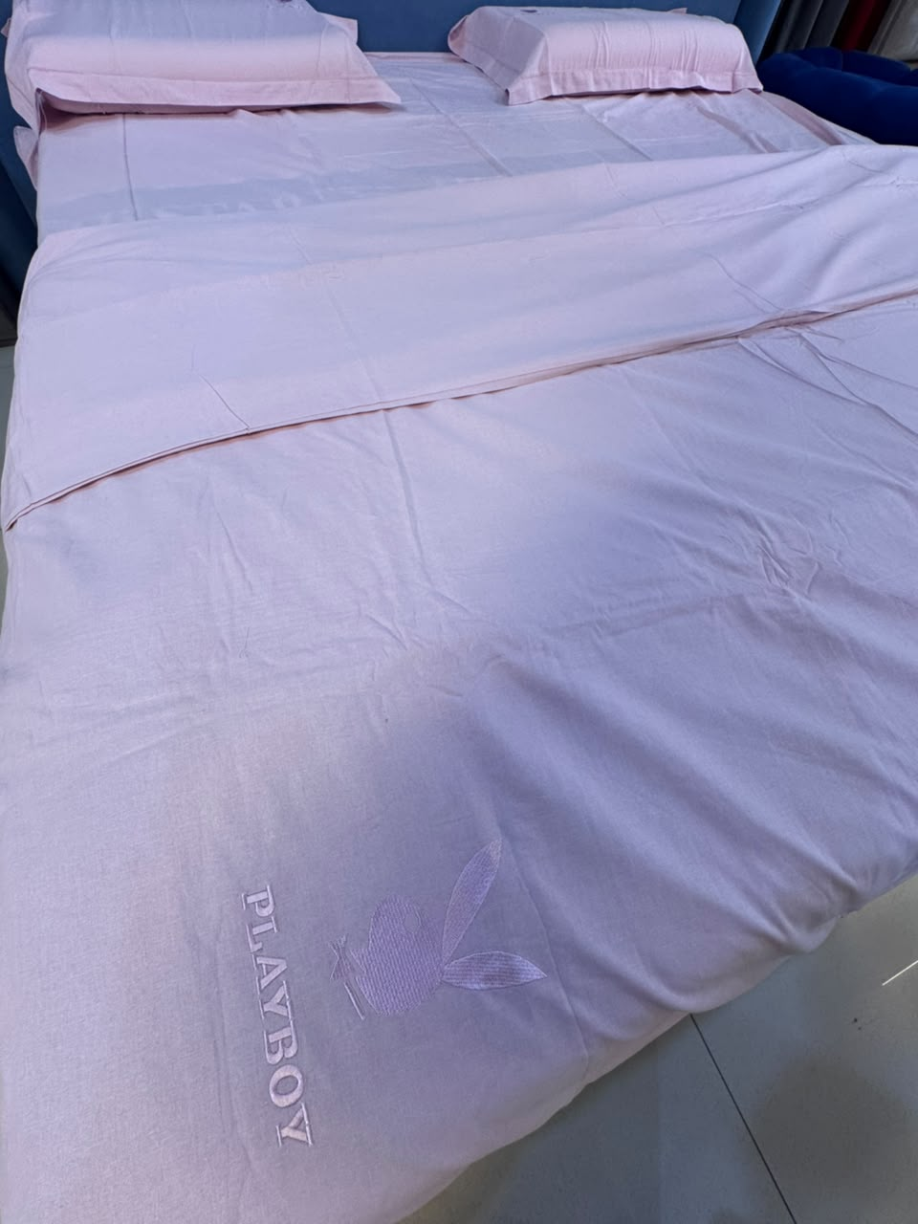
Rs. 4,600 Rs. 4,200 Save 9%
Includes: 1 x Bed Sheet, 2 x Pillow Covers, 1 x Quilt Cover
Fabric: Pure Cotton
Size: Double
Colors Available: Pink (pictured), Brown, Lavender
Description
Made from a pure cotton fabric in a soft solid tone, this quality has a smooth, everyday-soft hand-feel with a delicate tonal embroidered emblem detail on the top corner.
Features:
Soft and smooth texture provides a comfortable sleeping surface. Breathability helps regulate body temperature during sleep. Absorbs moisture and wicks away sweat, keeping you cool and dry. Hypoallergenic feature makes it a suitable choice for people with sensitive skin. Fast and everlasting colors. Natural and environment friendly.
Note: Colors shade/brightness may slightly differ due to photo shoot effects.

C BEDSHEET + QUILT COVER PATLAA

Lavender Damask
Regal damask medallions in soft lavender-pink.
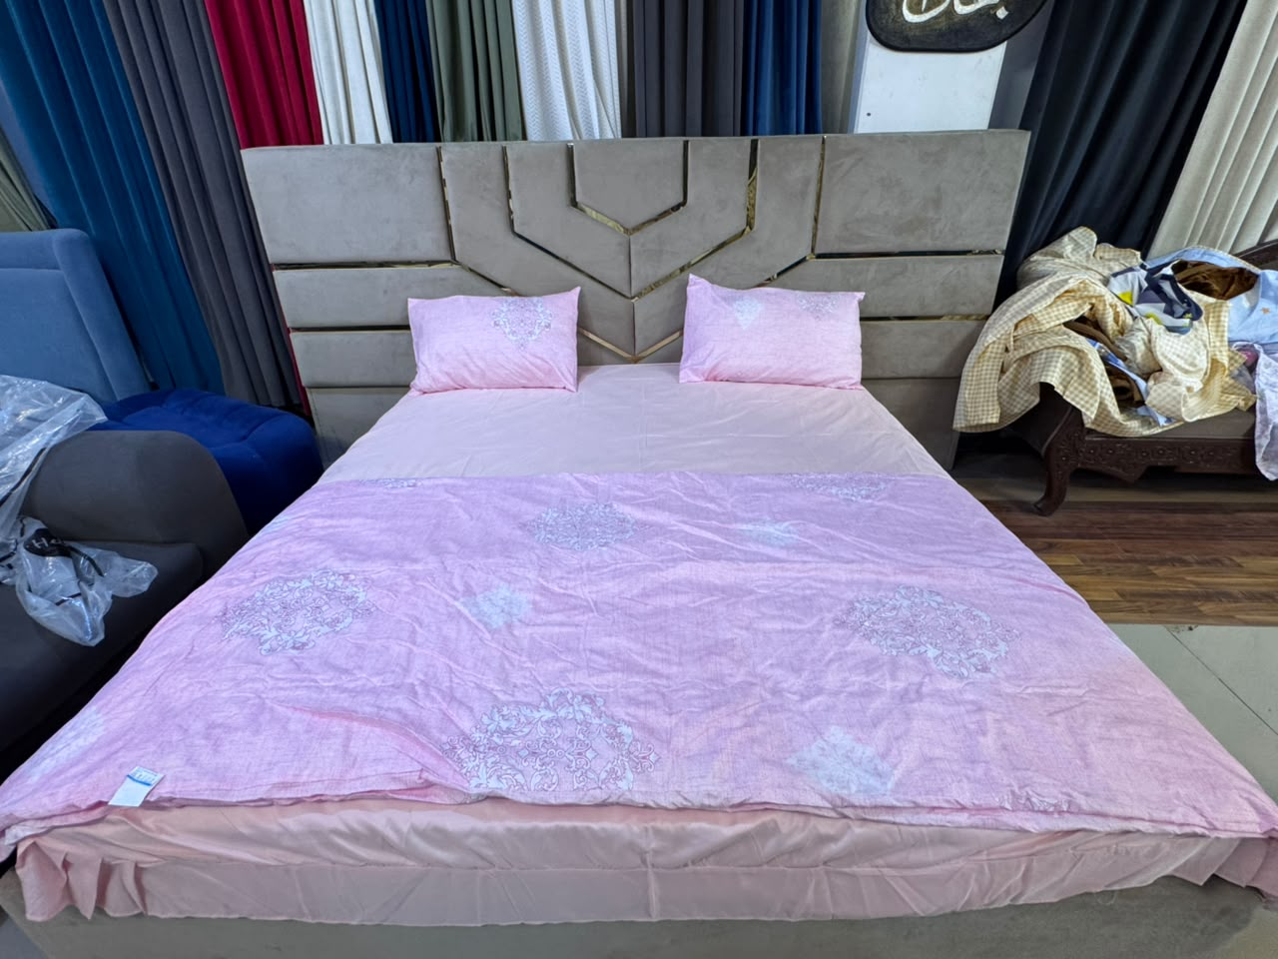
Rs. 6,300 Rs. 5,700 Save 10%
Includes: 1 x Bed Sheet, 2 x Pillow Covers, 1 x Quilt Cover (Patlaa)
Fabric: Cotton
Size: Double
Colors Available: Purple (pictured)
Description
Made from a soft cotton fabric, this quality pairs a solid-tone bed sheet with a coordinating printed thin quilt cover (patlaa) and matching pillow covers across every colourway in the collection.
Features:
Soft and smooth texture provides a comfortable sleeping surface. Breathability helps regulate body temperature during sleep. Absorbs moisture and wicks away sweat, keeping you cool and dry. Hypoallergenic feature makes it a suitable choice for people with sensitive skin. Fast and everlasting colors. Natural and environment friendly.
Note: Colors shade/brightness may slightly differ due to photo shoot effects.

C BEDSHEET + QUILT COVER PATLAA

Rose Ribbon Bouquet
Rose and hydrangea bouquets tied with pink ribbon.
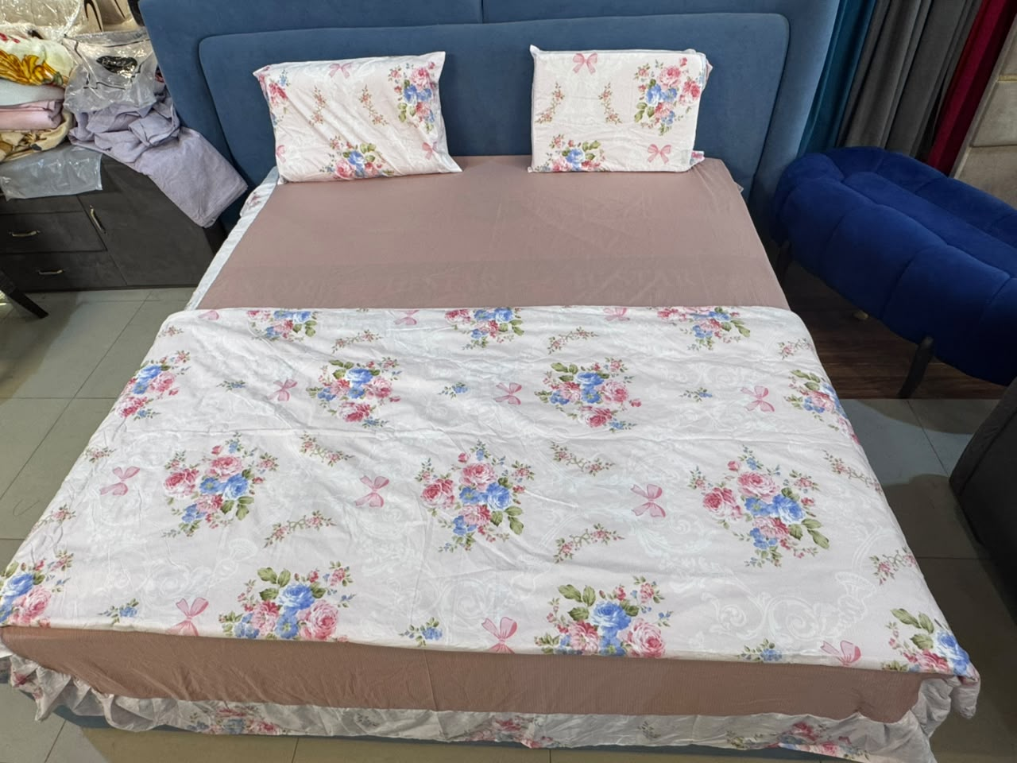
Rs. 6,300 Rs. 5,700 Save 10%
Includes: 1 x Bed Sheet, 2 x Pillow Covers, 1 x Quilt Cover (Patlaa)
Fabric: Cotton
Size: Double
Colors Available: Pink (pictured)
Description
Made from a soft cotton fabric, this quality pairs a solid-tone bed sheet with a coordinating printed thin quilt cover (patlaa) and matching pillow covers across every colourway in the collection.
Features:
Soft and smooth texture provides a comfortable sleeping surface. Breathability helps regulate body temperature during sleep. Absorbs moisture and wicks away sweat, keeping you cool and dry. Hypoallergenic feature makes it a suitable choice for people with sensitive skin. Fast and everlasting colors. Natural and environment friendly.
Note: Colors shade/brightness may slightly differ due to photo shoot effects.

C BEDSHEET + QUILT COVER PATLAA

Wildberry Blossom
Sweet floral bouquets with a handwritten love-note charm.
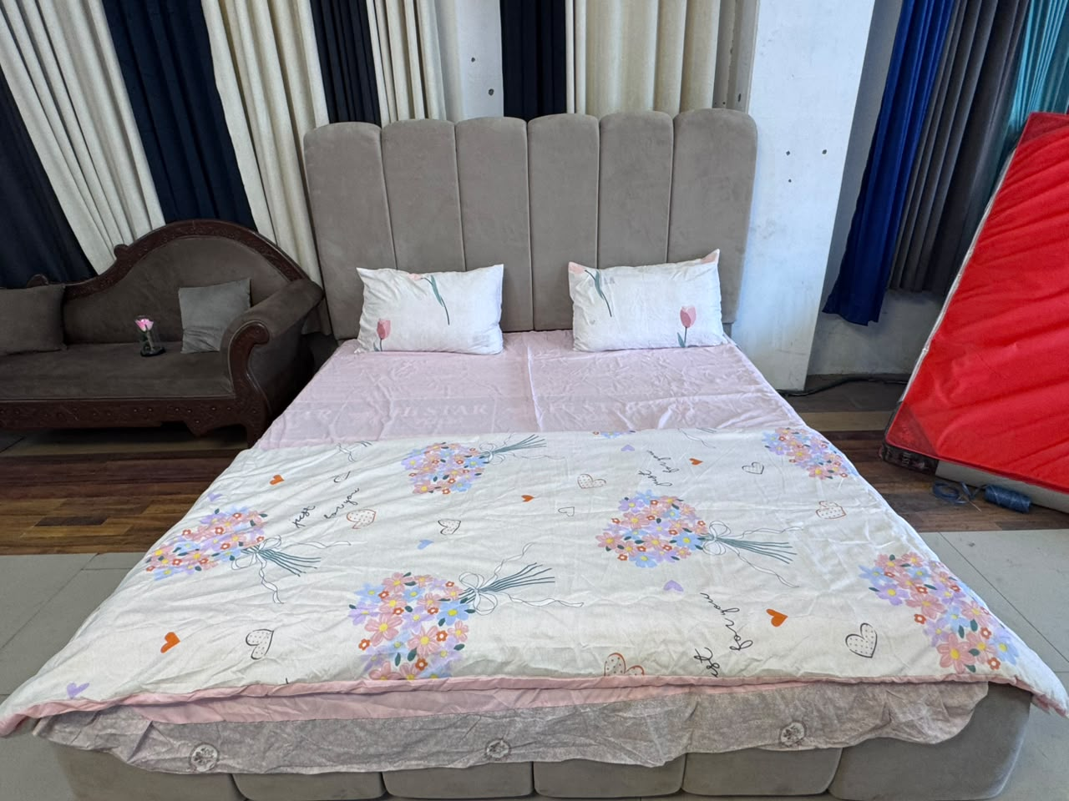
Rs. 6,300 Rs. 5,700 Save 10%
Includes: 1 x Bed Sheet, 2 x Pillow Covers, 1 x Quilt Cover (Patlaa)
Fabric: Cotton
Size: Double
Colors Available: Wildberry (pictured)
Description
Made from a soft cotton fabric, this quality pairs a solid-tone bed sheet with a coordinating printed thin quilt cover (patlaa) and matching pillow covers across every colourway in the collection.
Features:
Soft and smooth texture provides a comfortable sleeping surface. Breathability helps regulate body temperature during sleep. Absorbs moisture and wicks away sweat, keeping you cool and dry. Hypoallergenic feature makes it a suitable choice for people with sensitive skin. Fast and everlasting colors. Natural and environment friendly.
Note: Colors shade/brightness may slightly differ due to photo shoot effects.

C BEDSHEET + QUILT COVER PATLAA

Big Dream Chevron
Starry-night chevrons for big dreamers.
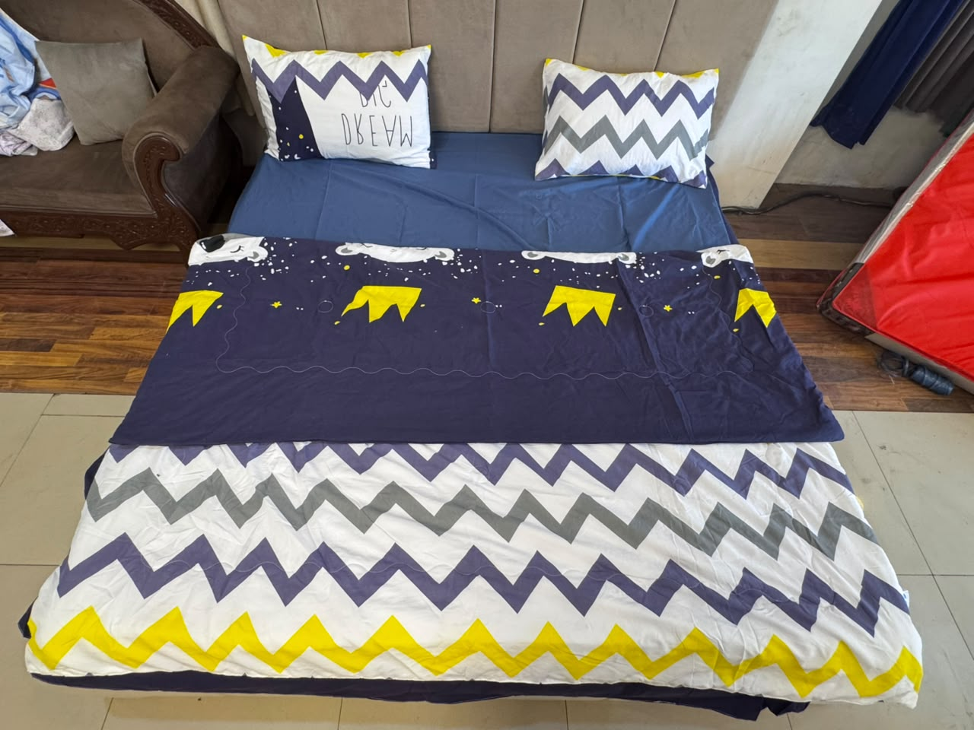
Rs. 6,300 Rs. 5,700 Save 10%
Includes: 1 x Bed Sheet, 2 x Pillow Covers, 1 x Quilt Cover (Patlaa)
Fabric: Cotton
Size: Double
Colors Available: Grey (pictured)
Description
Made from a soft cotton fabric, this quality pairs a solid-tone bed sheet with a coordinating printed thin quilt cover (patlaa) and matching pillow covers across every colourway in the collection.
Features:
Soft and smooth texture provides a comfortable sleeping surface. Breathability helps regulate body temperature during sleep. Absorbs moisture and wicks away sweat, keeping you cool and dry. Hypoallergenic feature makes it a suitable choice for people with sensitive skin. Fast and everlasting colors. Natural and environment friendly.
Note: Colors shade/brightness may slightly differ due to photo shoot effects.

C BEDSHEET + QUILT COVER MOTAA

Floral Whisper Mink
Plush warmth with a whisper of embroidered floral.
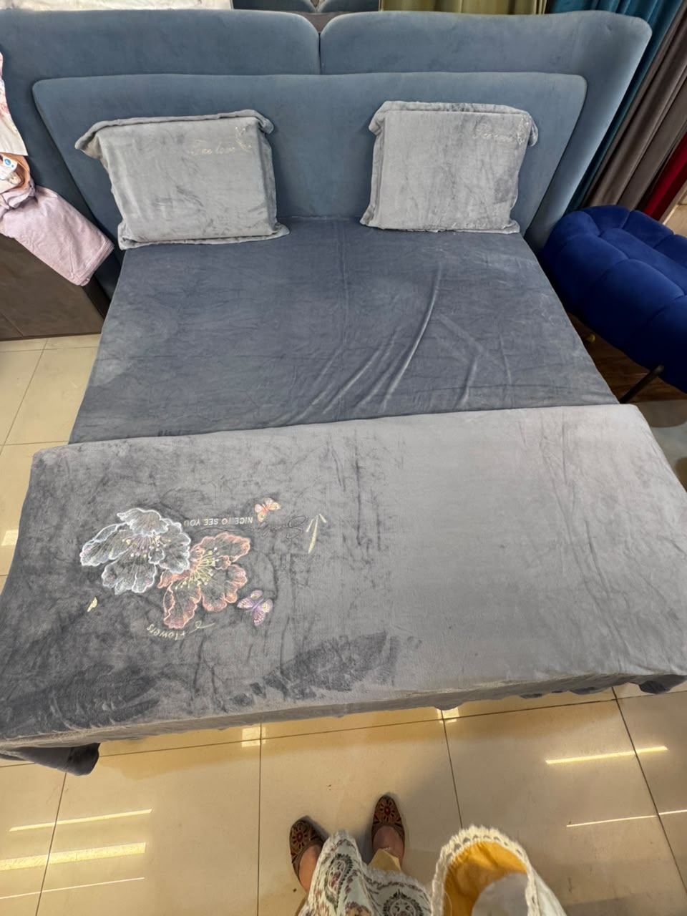
Rs. 8,500 Rs. 7,500 Save 12%
Includes: 1 x Bed Sheet, 2 x Pillow Covers, 1 x Quilt Cover (Motaa)
Fabric: Thick Mink/Plush
Size: Double
Colors Available: Grey (pictured), Pink, Blue
Description
Made from a thick, brushed mink-style plush fabric, this quality pairs a solid-tone bed sheet with a coordinating thick quilt cover (motaa) featuring a soft embroidered floral and butterfly accent, with matching pillow covers across the collection.
Features:
Thick, plush texture provides a warm, cozy sleeping surface. Soft brushed finish feels gentle against the skin. Embroidered floral and butterfly accent adds a decorative touch. Hypoallergenic feature makes it a suitable choice for people with sensitive skin. Fast and everlasting colors. Natural and environment friendly.
Note: Colors shade/brightness may slightly differ due to photo shoot effects.

C QUILT COVER KING

Honeycomb Weave Quilt Cover
Textured honeycomb comfort, king-sized.
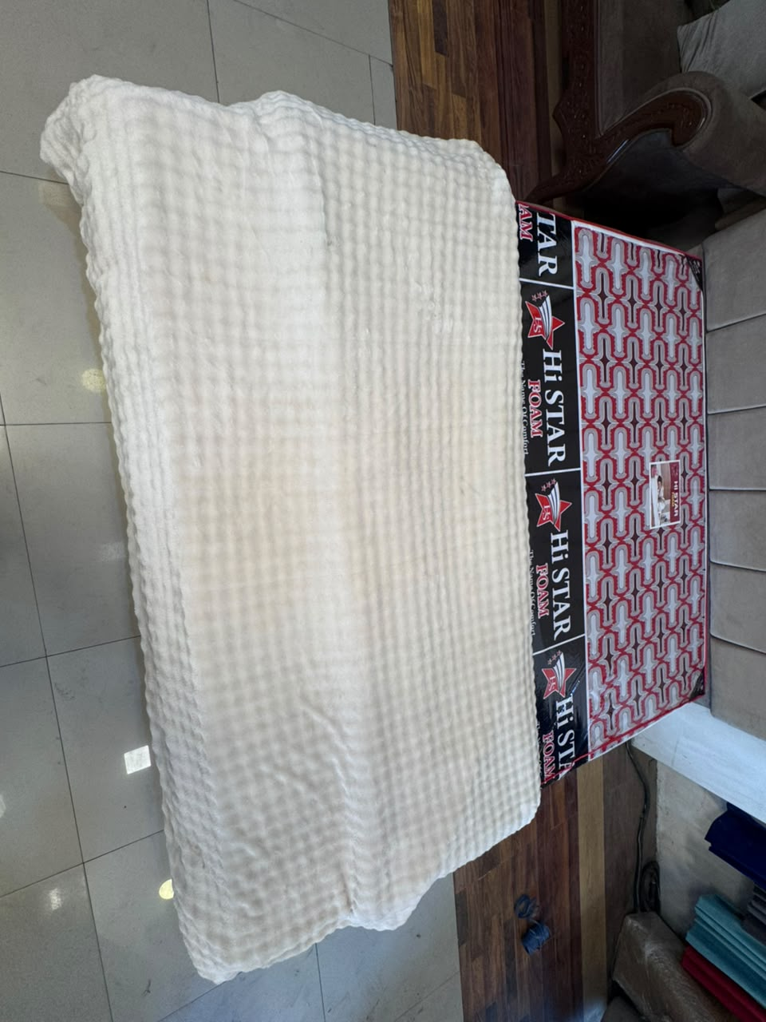
Rs. 5,000 Rs. 4,000 Save 20%
Includes: 1 x Quilt Cover
Fabric: Waffle-Textured Plush
Size: King
Colors Available: Off White (pictured), Pink, White
Description
Made from a soft, waffle-textured plush fabric, this quality is a standalone quilt cover with a cozy honeycomb-weave surface and a smooth reverse side.
Features:
Soft, textured waffle-weave surface adds visual and tactile interest. Plush texture provides a warm, cozy feel. Breathability helps regulate body temperature during sleep. Hypoallergenic feature makes it a suitable choice for people with sensitive skin. Fast and everlasting colors. Natural and environment friendly.
Note: Colors shade/brightness may slightly differ due to photo shoot effects.

C BEDSHEET SET 4PC

Slate & Tangerine
Cool slate grey meets warm tangerine contrast.
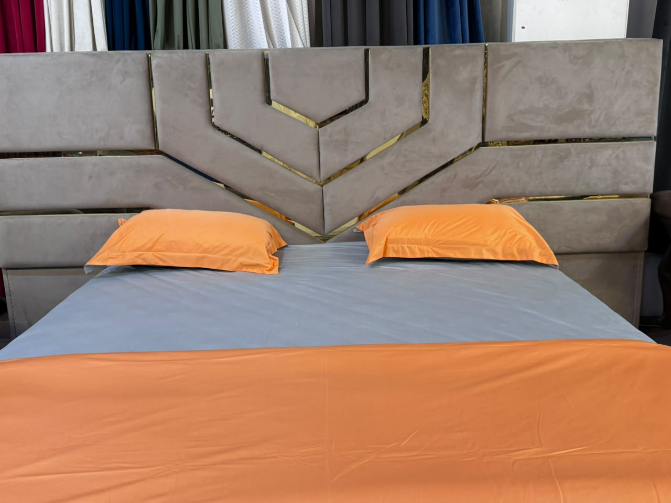
Rs. 7,000 Rs. 6,000 Save 14%
Includes: 1 x Bed Sheet, 2 x Pillow Covers, 1 x Quilt Cover
Fabric: Brushed Cotton
Size: Double
Colors Available: Grey & Orange (pictured)
Description
Made from a soft brushed cotton fabric, this quality pairs a solid slate-grey bed sheet with contrasting tangerine-orange pillow covers and a coordinating quilt cover for a bold two-tone look.
Features:
Soft and smooth texture provides a comfortable sleeping surface. Breathability helps regulate body temperature during sleep. Absorbs moisture and wicks away sweat, keeping you cool and dry. Hypoallergenic feature makes it a suitable choice for people with sensitive skin. Fast and everlasting colors. Natural and environment friendly.
Note: Colors shade/brightness may slightly differ due to photo shoot effects.

C TOWEL BEDSHEET + PILLOW COVER

Heritage Plaid
Classic heritage plaid in cozy brushed flannel.
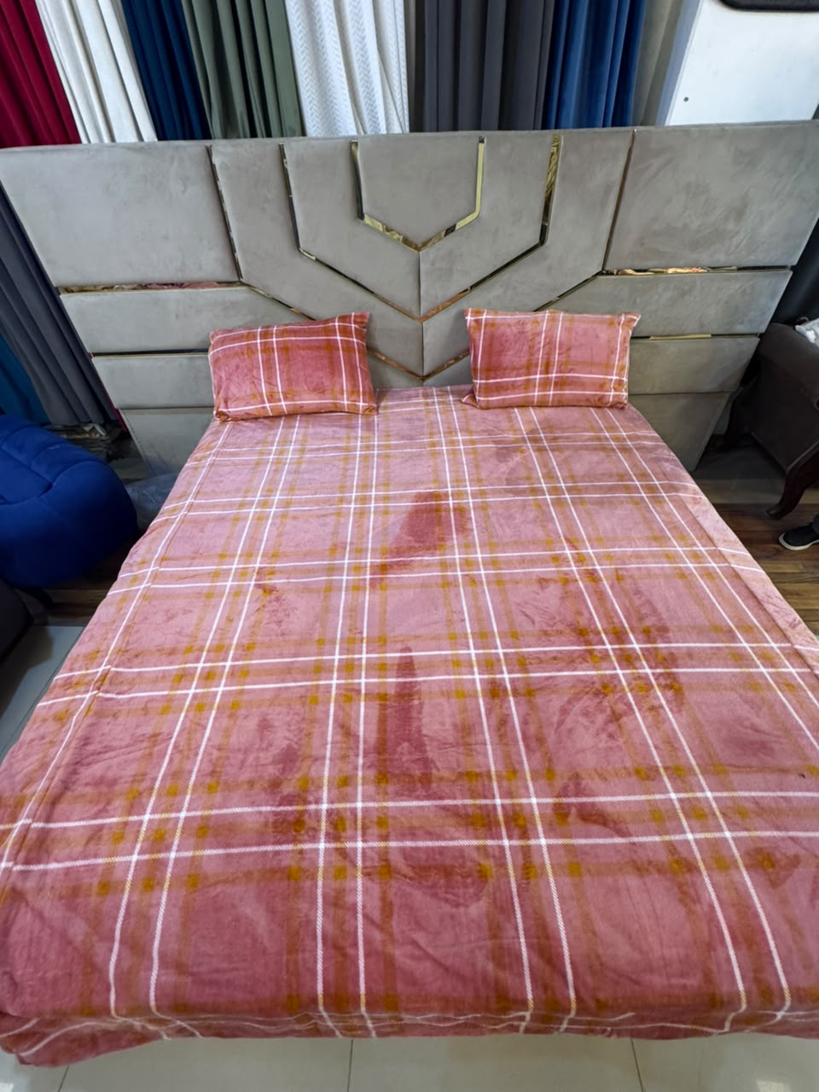
Rs. 3,000 Rs. 2,500 Save 17%
Includes: 1 x Bed Sheet, 2 x Pillow Covers
Fabric: Brushed Towelling-Effect Flannel
Size: Double
Colors Available: Fuchsia (pictured), Sky Blue, Green
Description
Made from a soft, brushed towelling-effect flannel fabric, this quality features a warm heritage plaid check woven in dusty rose, mustard, and white across the collection.
Features:
Soft, brushed towelling-effect texture provides a warm, cozy feel. Breathability helps regulate body temperature during sleep. Absorbs moisture and wicks away sweat, keeping you cool and dry. Hypoallergenic feature makes it a suitable choice for people with sensitive skin. Fast and everlasting colors. Natural and environment friendly.
Note: Colors shade/brightness may slightly differ due to photo shoot effects.

C SINGLE BEDSHEET SET

Daisy Meadow
Cheerful daisies scattered on a cool slate-blue ground.
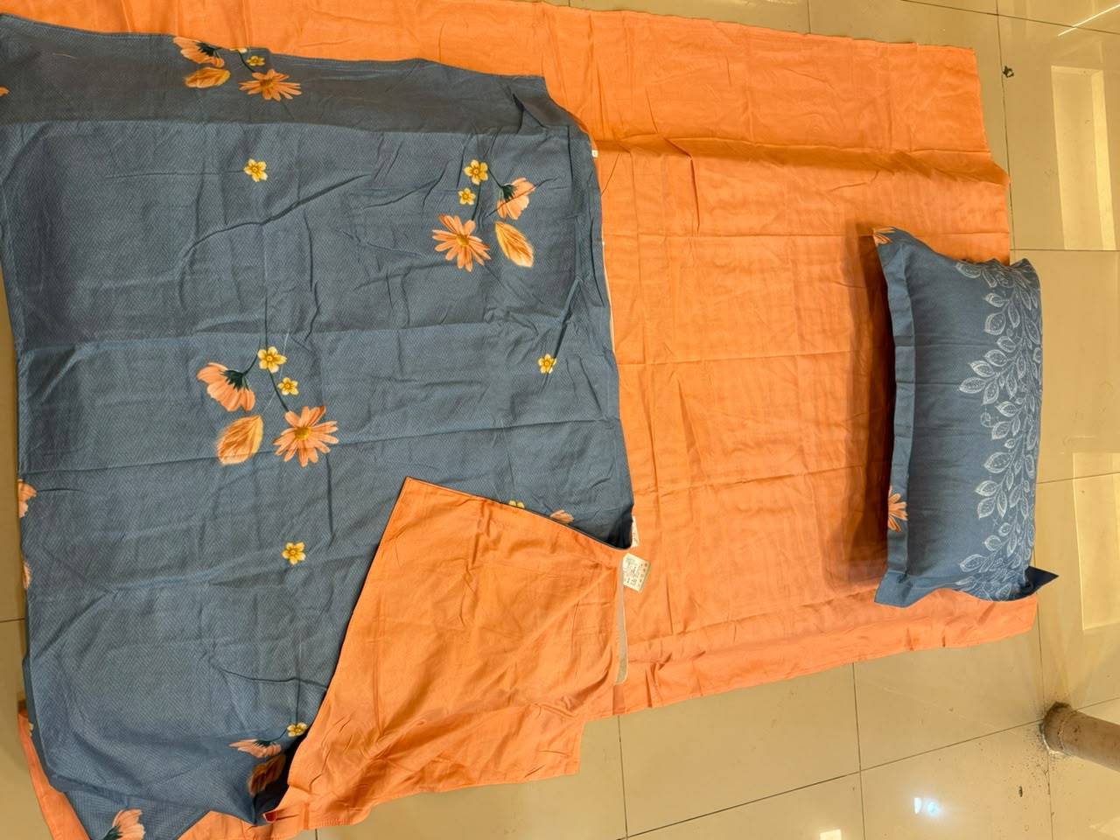
Rs. 5,000 Rs. 4,500 Save 10%
Includes: 1 x Bed Sheet, 1 x Quilt Cover, 1 x Pillow Cover
Fabric: Cotton
Size: Single
Colors Available: Orange & Slate Blue (pictured)
Description
Made from a soft cotton fabric, this quality is a single-bed set pairing a solid-tone bed sheet with a coordinating printed quilt cover and a matching pillow cover.
Features:
Soft and smooth texture provides a comfortable sleeping surface. Breathability helps regulate body temperature during sleep. Absorbs moisture and wicks away sweat, keeping you cool and dry. Hypoallergenic feature makes it a suitable choice for people with sensitive skin. Fast and everlasting colors. Natural and environment friendly.
Note: Colors shade/brightness may slightly differ due to photo shoot effects.

C SINGLE BEDSHEET SET

Magnolia Trellis
Painterly magnolia blooms along a soft mauve trellis.
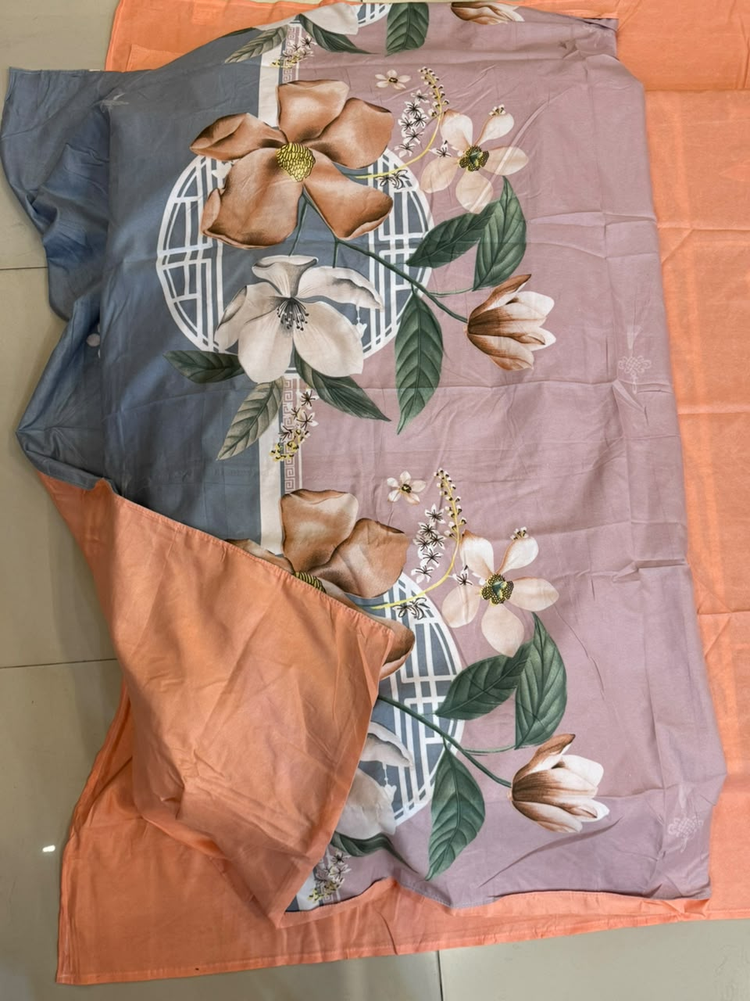
Rs. 5,000 Rs. 4,500 Save 10%
Includes: 1 x Bed Sheet, 1 x Quilt Cover, 1 x Pillow Cover
Fabric: Cotton
Size: Single
Colors Available: Orange & Mauve (pictured)
Description
Made from a soft cotton fabric, this quality is a single-bed set pairing a solid-tone bed sheet with a coordinating printed quilt cover and a matching pillow cover.
Features:
Soft and smooth texture provides a comfortable sleeping surface. Breathability helps regulate body temperature during sleep. Absorbs moisture and wicks away sweat, keeping you cool and dry. Hypoallergenic feature makes it a suitable choice for people with sensitive skin. Fast and everlasting colors. Natural and environment friendly.
Note: Colors shade/brightness may slightly differ due to photo shoot effects.

C SINGLE BEDSHEET SET

Blossom Strawberry
Playful blossoms and strawberries for a bright, easy look.
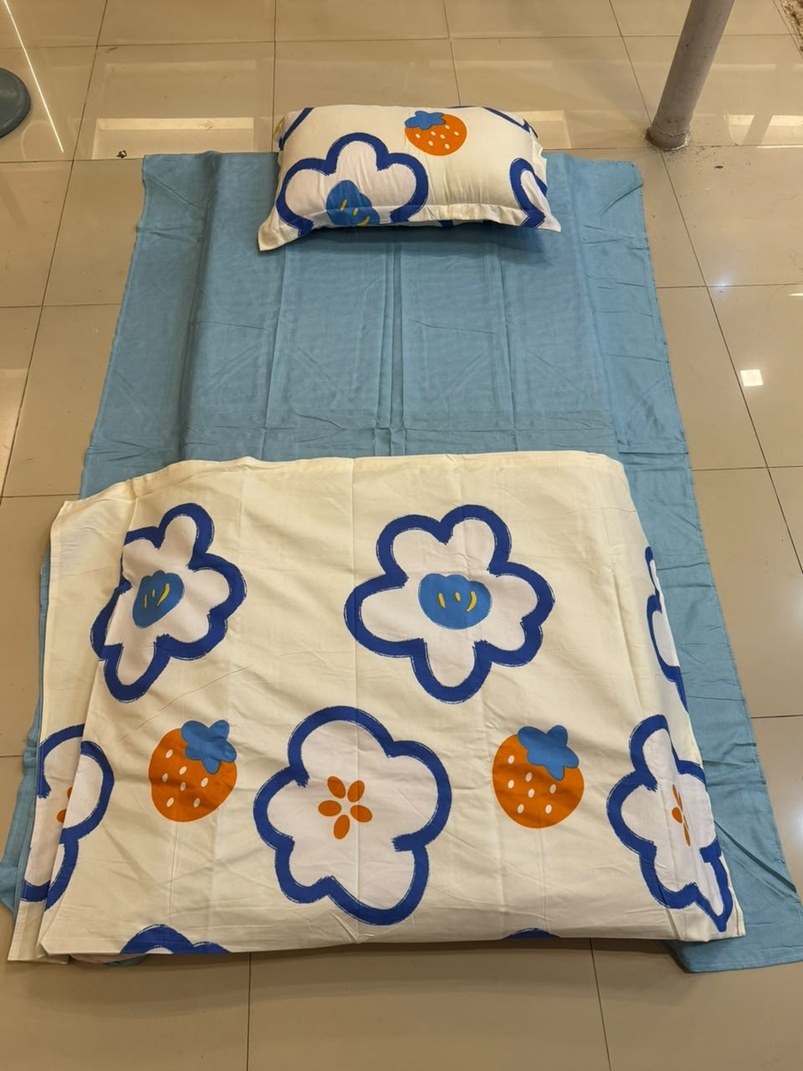
Rs. 5,000 Rs. 4,500 Save 10%
Includes: 1 x Bed Sheet, 1 x Quilt Cover, 1 x Pillow Cover
Fabric: Cotton
Size: Single
Colors Available: Sky Blue (pictured)
Description
Made from a soft cotton fabric, this quality is a single-bed set pairing a solid-tone bed sheet with a coordinating printed quilt cover and a matching pillow cover.
Features:
Soft and smooth texture provides a comfortable sleeping surface. Breathability helps regulate body temperature during sleep. Absorbs moisture and wicks away sweat, keeping you cool and dry. Hypoallergenic feature makes it a suitable choice for people with sensitive skin. Fast and everlasting colors. Natural and environment friendly.
Note: Colors shade/brightness may slightly differ due to photo shoot effects.

